2024 Annual Improvement Plan
MOE - 3599

Chairperson: Tim Saywell
Principal: Mike de Joux

Woodbury School
Woodbury School is situated 8kms inland from Geraldine, close to the Four Peaks range. We cater for students from Years 1- 6. We operate out of five classrooms, four of which operate as co-operative teaching teams using our recently developed innovative learning environments.

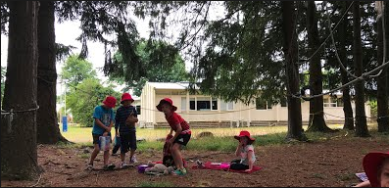
The school is well-resourced with a library and wireless internet throughout the school. There is an excellent range of teaching materials including ICT equipment to help the children find information and express themselves in a variety of ways.

The school playground is planted with a mixture of old established trees and New Zealand natives and is a safe and engaging place for students to explore, create and socialise. There is a large plantation for creative play, a challenging “low level” ropes course, a heated swimming pool, a bike track, a sandpit, an adventure playground, raised vegetable gardens and large shaded grass areas.

The integrated curriculum approach is used in the school and is planned to encourage the children to be responsible for their own learning through inquiry thinking. Extension programmes are implemented for the more able students and there is a strong learning support programme in place for any child requiring assistance.

The children’s progress and achievement is generally of a very good standard. This is demonstrated in the data collected from a variety of assessment strategies including many standardised testing tools.

A family atmosphere prevails throughout the school and parents are encouraged to be involved in all class and school activities. Annual events include a Flower and Craft show, Pet show, Triathlon, Matariki, Cross County, Athletics, Ski / Skate trip, Production / Arts Festival and Celebration of Learning at the end of the year. All are well supported by a community that is proud of its’ country character, caring culture and provision of an inclusive and well-balanced education.

Vision
Ko Tarahaoa me ona whanau kia whakaruruhau nga tapuwae ki te taumata
“My Footsteps to the Peaks. Every Footstep Counts”
Principles and Values
Woodbury School is an inclusive school where everyone is a learner and our steps aim to encourage life-long learning
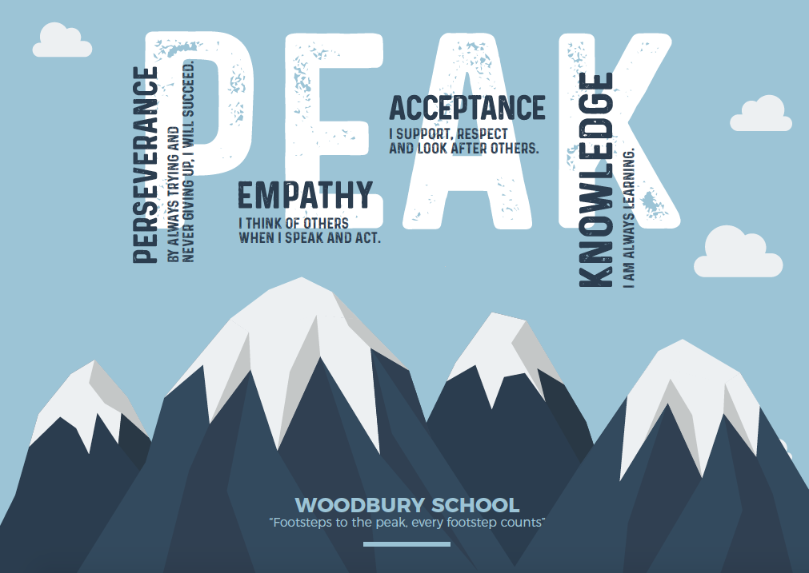
We aim for all learners to:
  - Continually try their best in order to achieve their goals
(Perseverance) (1.1)
  - Always think of how our actions can impact or support others (Empathy) (1.2)
  - Respect others and look after those in our community
(Acceptance) (1.3)
  - Value knowledge, be curious and solve problems
(Knowledge) (1.4)
Children will be aware of and show sensitivity to New Zealand’s cultural heritage and the unique position of Maori culture

Māori Dimensions and Cultural Diversity
Treaty of Waitangi – Woodbury School acknowledges the importance of the principles of the Treaty of Waitangi and its bi-cultural significance. Students will have the opportunities to learn about te reo Maori me ona tikanga.
Cultural Diversity – Cultural diversity is alive in our strategic plan and classroom programmes. The Woodbury School Board of Trustees and the staff are aware of the importance of cultural diversity with the school. A Te Reo programme is integrated into all classroom programmes, with teachers supported by a staff member with a specific Te Ao Maori responsibility. There is a Kapa Haka group involving any students who show an interest, and the school enters the Aoraki Flava Festival in alternative years.

If whanau request a higher level of Tikanga or Te Reo than is evident in Woodbury School’s present Maori programme, the staff and family will discuss and explore the following options:
- Further extend the existing programmes if and as appropriate.
- Combine with another school for parts of the programme.
- Dual enrolment with Correspondence School.
- Provide in-school support and resources to further help the inclusion of Te Reo and Tikanga

Self-Review
In 2023 we will continue to use our self-review process to look at curriculum and curriculum delivery, teacher practice, student engagement and wellbeing. Recent ERO publications are a useful guide that we can use as a tool to drive self-review and ensure we have complete coverage of each and every aspect that makes a successful school

Supporting Documentation
Budget/Finance | Self-Review Plan | Student Achievement Data
Assessment & OTJ Guide | Learning Support Programmes | Gifted & Talented Education
Curriculum Delivery Plan | Staff Organisation Folder | Teaching and Learning Resources
5 & 10 Year Property Plan | ICT & e-Learning (under review & development) | EOTC Programmes
Staffing and Enrolment | School Policies and Procedures (Schooldocs)

Woodbury School Strategic Goals
Principles and Values | Developing our Knowledge & Creativity
We aim for all learners to:  - Continually try their best in order to achieve their goals (Perseverance) (1.1)  - Always think of how our actions can impact or support others (Empathy) (1.2)  - Respect others and look after those in our community (Acceptance) (1.3)  - Value knowledge, be curious and solve problems (Knowledge) (1.4) | By the time our children leave this school, our aim is that they will:  - Have strong skills in and a positive attitude towards literacy and the use of effective communication tools (2.1)  - Use mathematical skills competently and be able to apply these to everyday situations (2.2)  - Appreciate, care for, question and explore their environment (2.3)  - Have a positive attitude to and skills for healthy living and physical activity (2.4)  - Develop skills to operate in our changing world and feel motivated to explore new learning pathways (2.5)  - Learning is supported by a detailed, responsive localised curriculum that addresses the needs of all students (2.6)
Developing our Environment | Developing our Relationships
- To provide a safe, attractive and stimulating environment for the children (3.1)  - To ensure learning is supported through up-to-date facilities, resources and equipment (3.2)  - To ensure high quality professional development opportunities for all staff and BoT (3.3)  - To provide a safe and healthy supportive working environment for all staff (3.4) | - To foster healthy partnerships and interactions between home, school and the community (4.1)  - To value and retain the country character of our rural school (4.2)  - To utilise our local environment and resources (4.3)  - To ensure students of all abilities and backgrounds are valued and included within our classrooms (4.4)  - To support parents to understand how their children are progressing and how they can support their learning and development at home (4.5)

Strategic Plan 2024-2026
Knowledge & Creativity | Core Strategies for Achieving Goals 2024-2026

Have strong skills in and a positive attitude towards literacy & the effective use of communication tools (2.1) | PD opportunities and RTLit support  Complete review and documentation of current practices in Year 1-3 Structured Literacy, incorporating practices at Year 4 – 6  “Target” groups tracked, monitored and supported  Prepare and upskill teachers in the use of the curriculum refresh in English  Upskilling Teacher Aides to better support learners in literacy sessions

Use mathematical skills competently and be able to apply these to everyday situations (2.2) | Refining the use of PRIME Maths  Revamping long term plans in maths to ensure coverage (possible CoL collaboration)  “Target” groups tracked, monitored and supported  Prepare and upskill teachers in the use of the curriculum refresh in Maths

Appreciate, care for, question and explore their environment (2.3) | Effectively establishing gardening team & using as part of curriculum (linking the “Growth” theme 2024)  Explore ways the school can use / teach sustainable practice (in teaching and in actions)  Local environment support (i.e. local rivers and streams, tidy up domain, “Barkers Creek” project, etc…)  Composting and worm farms  Farming trips incorporated into planning (“Paddock to Plate”)

Strategic Plan 2024-2026
Knowledge & Creativity | Core Strategies for Achieving Goals 2024-2026

Have a positive attitude to and skills for healthy living & physical activity (2.4) | Review LTP’s and coverage for Health & PE  Student and staff wellbeing (CoL and staff PD)

Develop skills to operate in our changing world & feel motivated to explore new learning pathways (2.5) | ICT equipment added to, as required  Review of Digital Curriculum expectations

Learning is supported by a detailed, responsive localised curriculum that addresses the needs of all students (2.6) | Curriculum Delivery Plan reviewed (in light of new curriculum “Refreshment”) – English and Maths focus 2024  Contracting Nick Williams in 2024, to enhance the school’s Strategic Direction Planning

Strategic Plan 2024-2026
Environment | Core Strategies for Achieving Goals 2024-2026

To provide a safe, attractive and stimulating learning environment for the children (3.1) | Planning for 2021 5YA property implementation and 10YPP (decking archgola, toilet build and staff end room development)  Planning ahead to 2026 5YA

To ensure learning is supported through up-to-date facilities, resources and equipment (3.2) | ICT equipment where required  Furniture where required in school  Purchase of numeracy resources, particularly in support of PRIME

To ensure high quality professional development opportunities for all staff and BOT (3.3) | PRIME Maths continuation (development around long term coverage planning)  Curriculum Refresh (ongoing – Maths and English 2024)  Nicholas Williams involvement 2024, to enhance the school’s Strategic Direction Planning  Transition / Literacy / Wellbeing (CoL) – increased CoL involvement to ensure it is relevant and meaningful  Teacher aide PD opportunities  KiVA – anti bullying PD  Review into culturally responsive practice

Strategic Plan 2024-2026
Environment | Core Strategies for Achieving Goals 2024-2026

To provide a safe and healthy supportive working environment for all staff (3.4) | Staff wellbeing focus continue  Initiatives to ensure staff working cohesively and feel part of a team  Integration of new staff

Strategic Plan 2024-2026
Relationships | Core Strategies for Achieving Goals 2024-2026

To foster healthy partnerships and interactions between home, school and the community (4.1) | Continued focus on integrating new families into school  Invite wider community including pre-schools and rest homes to specific events  Regular use of Classdojo to share learning

To value and retain the country character of our rural school (4.2) | Continue to enhance our outdoor spaces for children’s use  (seating, landscaping, continue gardens, composting)

To utilise our local environment and resources (4.3) | Use of Peel Forest / Waihi Bush / Orari Gorge etc…  Use of local working farms in EOTC visits

To ensure students of all abilities and backgrounds are valued and included within our classrooms (4.4) | Use of teacher aide support and programmes with targeted groups to support their learning  Dyslexia screening across school & PD to support students  Culturally Responsive practice review  KiVA anti-bullying programme implemented  Focus each term on specific PEAK value

To support parents to understand how their children are progressing and how they can support their learning and development at home (4.5) | Update our website with supports for parents to explore for their child’s learning  Developing use of HERO for reporting to parents and progress / achievement levels

Woodbury School Annual Improvement Action Plan
(more specific actions for important focus areas 2024)

Specific Focus | Link to “equity & excellence” | Resources / People | Actions to complete
Cultural Practices Review (4.1, 4.4) | Students, families and staff need to feel valued and their culture validated, in order to achieve a sense of belonging and making progress at school.  We want to review and enhance staff knowledge, awareness and practices to further support all aspects of our school “Culture”. This includes not only Te Ao Maori and Te Reo, but how we interact and engage with all students and whanau. | Staff  Students  Families  BOT | - Using tools such as Hautu, Poutama Reo and the Hikairo Schema to review current practices  - BOT discussion around cultural competency and where we are at currently as a school.  - Review of current cultural practices and initiating further development (led by Becky Talbot)  - Review of the use of Ka Hikitia, how this fits with the new refreshed curriculum and with Woodbury School.  - Review the requirements of teaching Te Reo in primary schools  - Further exploration of the NZ Histories Curriculum  - Increased emphasis on each of the PEAK values  - Establishment of KiVa anti-bullying programme
Progress Report / Future Focus:

Continuation and completion of review and documentation of current practices in Year 1-3 Structured Literacy, and how we then operate in Year 4-6  (2.1, 2.6, 3.2, 3.3) | Achievement in literacy is a key to further achievement in education and in future careers. Structured Literacy is a proven model by which teachers can raise student achievement, particularly with those students with learning difficulties such as dyslexia. | Year 1-3 staff  Led by Bridget Patrick  Principal  Linda Esselmont (RTLit)  Kahui Ako involvement | - Consolidation of current practices implemented in 2023.  - Focus on What we are doing in Year 4-6, how we support those not achieving, how we continue the good practices already in place, and extending the Liz Kane spelling programme to this area  - Session 3 of the CoL literacy PLD, around fluency and comprehension  - Specific PLD for teacher aides to support teachers and students  - Additional day for Bridget Patrick, mornings to work with students and afternoons rotating around classes to support teachers and programmes.  - Finalise assessments that are used, and tracking sheets  - Purchasing of any resources required  - Documentation of all the above, to establish what literacy teaching looks like across the school.
Progress Report / Future Focus:

Maths  - Implementation of the new PRIME Maths books (and using the new LTP) across the school, and evaluating the impact of this programme (2.1, 3.3)  - Staff PD around effective teaching and learning in maths through TLF maths (2.1, 2.6, 3.3) | Maths is one of our core focus areas. We hope that by establishing a more cohesive system (PRIME) across the school we can foster high levels of engagement and achievement for all students.  We are also part of a professional development group, looking at enhancing our teaching programmes, teacher knowledge and skills. | Mike & Sarah (as leaders in maths)  PRIME Resources  TLF Maths sessions  New LTP resource  Staff – feedback and development sessions | - Baseline data collected  - Resources identified and purchased  - Teachers familiarise themselves with resources  - Use of new LTP to ensure coverage  - Purchasing of additional resources and equipment to support teaching and learning  - Ongoing PD opportunities and staff discussions to support teachers’ understanding and delivery  - Answering key questions identified around PRIME delivery  - Attendance at Maths PD sessions (Mike/Sarah/Jud/Rachelle/Bron) and feeding these back to staff  - Finalising assessments used (which compliment PRIME and support teacher judgements)  - Creation of document that identifies all aspects of maths delivery at Woodbury School
Progress Report / Future Focus:

Student Achievement Target for 2024 – No: 1 Maths

Strategic Goal |  | Annual Goal |  | Annual Target
Student Achievement  Use mathematical skills competently and be able to apply these to everyday situations (2.2) |  | High quality teaching and learning programmes with emphasis on literacy and numeracy. |  | Maths: To achieve over 90% of our children across the school at and above in Maths

History | The data shows us that schoolwide in maths we have 84% of students achieving at or above curriculum expectations. W are aware of the need to support those who continue to struggle in maths, and we have specific strategies in place in 2024 to try and address these needs.

Action | Actions to Achieve Target | Led by | Progress Statement
 | Continued implementation of PRIME maths across the school. Includes professional development across all teaching staff (including TA’s) and purchase of resources | Principal / teachers
 | Part of South Canterbury Cluster receiving professional development through TLF (The Learner First). This focuses on teacher development, teacher understanding and student engagement. This year we have 5 staff attending | Principal / 4 teachers / wider staff
 | Evaluation of current materials used within mathematics teaching, how this looks with PRIME maths and invest in anything required | Principal / teachers
 | Ongoing evaluation as to how Numicon can be incorporated to support student learning, as well as Numicon use in the Year 1-2 area of school | Bridget / Maureen / Jud / Vikki
 | Continued tracking of students not achieving at expectations using learning registers, with regular reviews and identification of areas of support. | SENCO / Principal
 | Staff professional development around the curriculum refresh (as and when curriculum info is released) | Teachers
 | Review assessment tools used (may be MOE guidance around these) | Teachers

Student Achievement Target for 2024 – No: 2 School Culture

Strategic Goal |  | Annual Goal |  | Annual Target
Student Achievement  To ensure students of all abilities and backgrounds are valued and included within our classrooms (4.4) |  | High quality teaching and learning programmes with emphasis on literacy and numeracy. |  | Culture: We are focusing on students throughout the school being confident learners who are comfortable and happy in our school environment.

History | At Woodbury School we strongly believe that student learning is heavily influenced by a students’ sense of belonging. If we focus on ensuring children are safe, confident and happy at school we know this will be incredibly beneficial to their willingness and ability to learn.  This goal links in with our review around all aspects of school culture – how we use and promote our school PEAK values, our use and delivery of te reo and tikanga Māori, introduction of the KiVa anti-bullying programme, and a Kahui Ako focus and PLD around relationship-based learning

Action | Actions to Achieve Target | Led by | Progress Statement
 | Re-newed focus on our School Values of Perseverance, Empathy, Acceptance and Knowledge | Staff
 | Student feedback via regular “Student Council” meetings and student wellbeing survey | Principal
 | Review around te reo curriculum, and tikanga Māori at Woodbury School | Becky / Principal / Staff
 | Relationship-based professional development (Teaching to the North-East) via the Kahui Ako | Staff
 | Implementation of the KiVa anti-bullying programme | Lead “team” / Staff
 | Opportunities for older students to lead and set the tone and example for younger students (continue fostering “family” feel throughout school) | Staff (Year 6)

